UGLY CAKE CONTEST
CARROLL COUNTY FAIR
Friday, July 13th, 2018 @ 5:00 PM
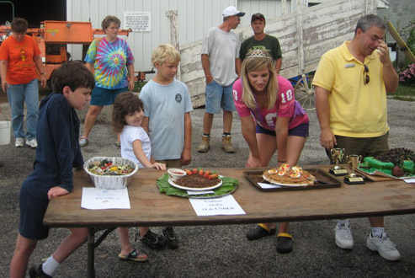
Rules:
- Ugly as can be: the uglier the better (NO mold can be on the cake)
- Use your imagination. Please use discretion in your assortment of garnishments
- All ingredients and decorations must be edible
- Entries will be judged on looks alone
- A real cake must be used
- No cakes are to be longer than 18”
- Please include a recipe card with recipe, ingredients and age
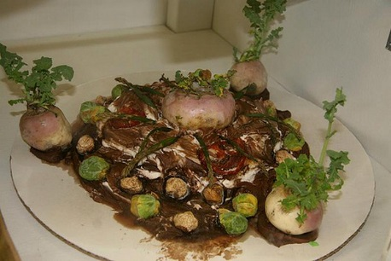
- Please have your cakes at the Exhibitor Building between 5:00 & 5:30 pm. Judging will begin between 5:30 & 6:00.

Three Classes (determined by Age) & Prizes:
18+ age group:
1st Place: $50 cash from the Carroll County Fair Association
2nd Place $25 cash from the Carroll County Fair Association
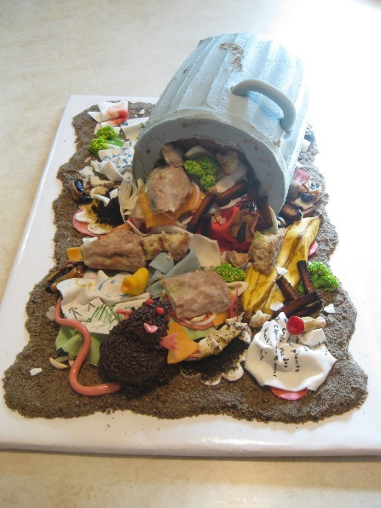
10 - 17 age group:
1st Place: $50 cash from the Carroll County Fair Association
2nd Place $25 cash from the Carroll County Fair Association

9 and under age group:
1st Place: $50 cash from the Carroll County Fair Association
2nd Place $25 cash from the Carroll County Fair Association
